Address  [Contact Number] |  | 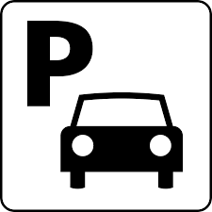
Parking Receipt
Date: 00/00/00 | Time: 00:00 PM
Duration: [Hours] [Minutes]
PAID: $0
THANK YOU!
AND DRIVE SAFELY

